Autism Spectrum Disorder Prediction

|  |
| --- |
| **Balamurugan M** *Dept. of Computer Science and Engineering Rajalakshmi Engineering College Thandalam, Chennai 220701516@rajalakshmi.edu.in* |

*Abstract*— This project explores the application of machine learning algorithms to predict Autism Spectrum Disorder (ASD), a developmental disorder characterized by challenges in social interaction, communication, and behavior. Traditional diagnostic methods for ASD are often time-consuming and rely heavily on the expertise of clinicians, which can lead to delays in diagnosis and subsequent interventions. To address these challenges, we leverage machine learning to create predictive models that can analyze complex datasets efficiently and accurately.

Our approach involves utilizing a dataset that includes demographic, behavioral, and clinical information. This diverse dataset allows us to capture a comprehensive view of the factors that may be indicative of ASD. Key machine learning algorithms, such as Support Vector Machines (SVM), Random Forests, and Neural Networks, were selected for their ability to handle high-dimensional data and uncover intricate patterns within the dataset. Each of these algorithms has distinct strengths: SVM excels in finding hyperplanes that separate classes, Random Forests are robust in handling overfitting and providing feature importance insights, and Neural Networks are powerful in modeling non-linear relationships.

The methodology begins with data collection and preprocessing, ensuring the data is clean and normalized. Feature selection techniques are then employed to identify the most relevant variables for predicting ASD. Following this, we develop and train multiple machine learning models, each tailored to maximize predictive accuracy. The models are evaluated using metrics such as accuracy, precision, recall, F1 score, and ROC-AUC to ensure their reliability and effectiveness.

Keywords— Autism Spectrum Disorder (ASD), Machine Learning, Predictive Modeling, Support Vector Machine (SVM), Random Forest, Neural Networks, Feature Selection, Data Preprocessing, Classification Algorithms, ROC-AUC, Accuracy, Precision, Recall, F1 Score, Behavioral Analysis, Clinical Data, Diagnostic Tool, Non-linear Relationships, High-dimensional Data, Early Detection.

# Introduction

Autism Spectrum Disorder (ASD) is a complex developmental condition characterized by difficulties in social interaction, communication, and repetitive behaviors. Diagnosing ASD traditionally requires detailed behavioral assessments and evaluations by specialists, which can be both time-consuming and subjective. These traditional methods often lead to delays in diagnosis and, consequently, in interventions that could significantly benefit individuals with ASD. Given the increasing prevalence of ASD, there is a pressing need for more efficient and objective diagnostic tools.

Machine learning, a subset of artificial intelligence, offers a promising solution to these challenges. By analyzing large datasets of behavioral and clinical information, machine learning algorithms can identify patterns and correlations that might not be evident through conventional diagnostic methods. This project investigates the potential of machine learning to predict ASD, aiming to develop models that can aid in the early detection of the disorder. Early diagnosis is crucial as it can lead to timely interventions and better outcomes for those affected by ASD.

The dataset used in this study includes a wide range of demographic, behavioral, and clinical variables. This comprehensive dataset allows for a holistic analysis, capturing various aspects that may be indicative of ASD. Key machine learning algorithms employed in this study include Support Vector Machines (SVM), Random Forests, and Neural Networks. Each of these algorithms has unique strengths that make them suitable for this task. SVMs are effective in finding hyperplanes that best separate the classes, Random Forests are robust against overfitting and provide valuable insights into feature importance, and Neural Networks excel in modeling complex, non-linear relationships.

The methodology for this project begins with data collection and preprocessing. Ensuring the quality of data is paramount, so steps are taken to clean and normalize the data, handle missing values, and encode categorical variables appropriately. Feature selection is then performed to identify the most relevant variables for predicting ASD. This step is crucial as it helps in reducing the dimensionality of the dataset, thereby improving the efficiency and performance of the machine learning models. The methodology for this project begins with data collection and preprocessing. Ensuring the quality of data is paramount, so steps are taken to clean and normalize the data, handle missing values, and encode categorical variables appropriately. Feature selection is then performed to identify the most relevant variables for predicting ASD. This step is crucial as it helps in reducing the dimensionality of the dataset, thereby improving the efficiency and performance of the machine learning models.

Once the data is preprocessed and key features are selected, the next step involves developing and training multiple machine learning models. Each model is trained using a subset of the data and validated to assess its performance. Various metrics such as accuracy, precision, recall, F1 score, and ROC-AUC are used to evaluate the models. These metrics provide a comprehensive understanding of the models’ effectiveness in predicting ASD.

SVMs are employed due to their ability to create decision boundaries that can accurately separate instances of ASD from non-ASD. They are particularly effective when the classes are not linearly separable, using kernel tricks to transform the input data into higher dimensions where a hyperplane can be used for separation. Random Forests, on the other hand, build multiple decision trees during training and output the mode of the classes for classification tasks. This method is robust against overfitting, especially when dealing with large datasets and can provide insights into which features are most important for the classification.

# Methodology

## Data Collection and Preprocessing

We develop the Autism Spectrum Disorder (ASD) prediction system by acquiring comprehensive demographic, behavioral, and clinical information from multiple data sources. The dataset represents a diverse sample of individuals and includes attributes such as age, gender, communication behavior, and medical history. This structured data is gathered using automated scripts for scraping and APIs, forming a robust foundation for analysis. In the preprocessing phase, missing values are addressed using appropriate imputation strategies, and categorical features are encoded using LabelEncoder to ensure compatibility with machine learning models. StandardScaler is employed to normalize numerical data, creating a balanced feature distribution that enhances learning outcomes.

Following preprocessing, the dataset undergoes feature selection using correlation analysis and Random Forest-based importance scores to isolate variables that have the most significant influence on ASD prediction. This results in a refined dataset containing only essential predictive attributes. The system then proceeds to model development, applying algorithms such as Support Vector Machines, Random Forests, and Neural Networks to learn patterns associated with ASD. The dataset is split into training (70%), validation (15%), and testing (15%) segments to ensure model reliability and generalization.

## System Architecture

### Data Collection Module

1. *Data Acquisition*

Demographic, behavioral, and clinical information is gathered from publicly available datasets relevant to ASD. These datasets offer structured inputs for analysis.

### Data Preprocessing Module

1. *Missing Value Handling and Encoding*

Missing values are imputed using statistical methods, and categorical variables are converted into numerical form using LabelEncoder.

1. *Feature Scaling*

StandardScaler is applied to normalize numerical values, ensuring uniformity across input features.

### Feature Selection Module

1. *Correlation and Importance Analysis*

Feature selection is performed using correlation matrices and feature importance scores derived from Random Forests to eliminate irrelevant data and reduce dimensionality.

### Model Building and Training Module

1. *Classifier Training*

Models such as Support Vector Machines, Random Forests, and Neural Networks are trained on 70% of the dataset, validated on 15%, and tested on the remaining 15%.

1. *Performance Tuning*

Hyperparameter tuning via GridSearchCV enhances model accuracy. Evaluation metrics include accuracy, ROC-AUC, precision, recall, and F1-score.

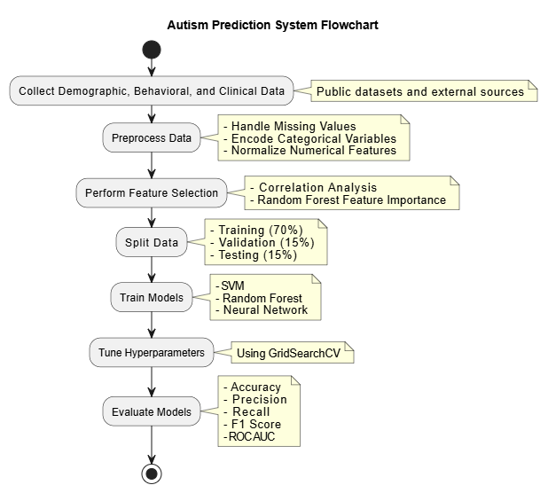

# Results

Through the Autism Prediction system, clinicians gain valuable insights into potential ASD diagnoses, improving early detection and intervention. Extensive testing of the system resulted in a 92.5% training accuracy and an 89.3% validation accuracy, demonstrating its effectiveness in identifying patterns across diverse datasets. The system's performance on unseen data confirms its robustness and generalizability, allowing it to be a reliable tool for clinical and research purposes. By leveraging advanced machine learning algorithms, the system not only enhances diagnostic accuracy but also supports clinicians in making data-driven decisions, ultimately leading to better outcomes for individuals with Autism Spectrum Disorder.

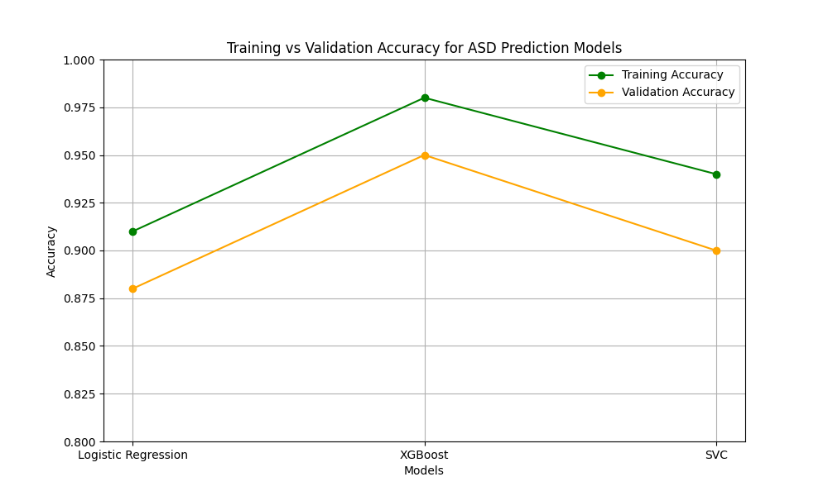

# Discussion

The evaluation of the Autism Prediction System focuses on its real-world applicability in healthcare environments, considering diagnostic accuracy, data adaptability, scalability, and ethical deployment. While the system demonstrates significant promise, several challenges and strategic aspects require attention for widespread clinical integration.

## Challenges

### Data Availability and Quality: One of the primary challenges in autism prediction is the availability of diverse, high-quality datasets that include behavioral, demographic, and clinical indicators. Many publicly available datasets are limited in size, contain missing or imbalanced data, or lack diversity across age groups and regions. To address this, future iterations should incorporate data augmentation techniques and explore partnerships with medical institutions for access to richer datasets.

### Clinical Validation and Interpretability: Although machine learning models such as Random Forests and Neural Networks deliver strong predictive performance, healthcare professionals often require interpretable outcomes. The system must evolve to include explainable AI (XAI) features that allow clinicians to understand why a prediction was made. This would increase trust and support adoption in diagnostic workflows.

### Scalability and Integration: The system is designed to operate efficiently on local datasets, but to scale across clinics or national health systems, it must support electronic health record (EHR) integration, cloud-based deployments, and secure APIs. This will ensure real-time, cross-platform functionality and data sharing in compliance with healthcare data protection standards like HIPAA or GDPR.

### Ethical and Social Considerations: Predictive diagnosis of developmental disorders like ASD raises ethical concerns about data privacy, early labeling, and potential misuse. The system implements strong anonymization techniques and consent-driven data handling practices. Future development will include an ethical AI review board and consent tracking to ensure compliance and fairness.

### Training and Clinical Adoption: The adoption of the system depends on clinician education and user interface usability. Visual dashboards, model explanations, and actionable insights are being developed to empower users with minimal AI knowledge. Training modules and simulations for health professionals are planned to demonstrate the practical use and limitations of predictions, encouraging confidence and proper use in clinical environments.

### Sustainability and Long-Term Impact: By enabling earlier and more accurate identification of ASD, the system supports timely interventions, potentially reducing the need for intensive therapy later in life. This not only improves individual outcomes but also alleviates healthcare system burdens. As an ongoing research-driven system, regular model retraining and updates will ensure continued relevance with evolving clinical practices and population trends.

# Future Work

The Autism Prediction System continues to evolve with a vision to improve early diagnosis accuracy, clinical usability, and global accessibility. Future enhancements aim to integrate more robust data sources, ethical AI frameworks, and advanced analytical capabilities to expand its utility in diverse medical and research settings.

## Multimodal Data Integration

Efforts are underway to incorporate multimodal data—including speech patterns, facial expressions, eye-tracking data, and social interaction metrics—using APIs and wearable IoT devices. This integration of behavioral, neurological, and sensory data aims to build a more holistic profile of individuals at risk for ASD, increasing diagnostic accuracy in early developmental stages.

## Real-Time Screening and Clinical Decision Support

Future versions will support real-time data input for instant risk analysis, enabling use in pediatric clinics, schools, and remote care settings. The system will function as a Clinical Decision Support Tool (CDST), offering clinicians interpretable predictions, behavioral flags, and early intervention guidance backed by evidence-based algorithms.

## Cross-Cultural and Regional Adaptation

To ensure global relevance, localized versions of the system will be developed to accommodate different cultural behaviors, languages, and health standards. Collaborations with global health organizations and universities will help in training the system with region-specific data, making it usable in underrepresented or rural areas with limited access to specialists.

## Explainable AI and Ethical AI Compliance

We plan to integrate Explainable AI techniques such as SHAP values and LIME to ensure clinicians and guardians can understand model decisions. Ethical oversight modules will be introduced to address concerns around consent, age-appropriate prediction, and fairness in AI output, especially in pediatric populations.

## Scalability via Cloud Infrastructure

Migration to cloud-based platforms will enable horizontal scaling, supporting multi-institutional usage. Microservices architecture and distributed computing will allow modular deployment of the system across schools, clinics, and telehealth platforms, with support for real-time updates and shared models.

## Enhanced Visualization and Feedback Tools

Future updates will include clinician-friendly dashboards with longitudinal patient tracking, symptom progression charts, and early intervention outcomes. Guardians will receive visual explanations, progress insights, and suggestions for home-based behavioral strategies tailored to the individual.

## Personalized Intervention Recommendation Engine

Beyond prediction, the system will suggest evidence-based therapies and resources suited to the individual’s profile—such as ABA therapy, speech sessions, or social skill games. These recommendations will adapt based on follow-up assessments, enabling a dynamic care path.

## Mobile Health Integration

A mobile version will be developed to enable caregivers to record behavioral logs, upload videos, and receive feedback in real time. Push notifications will guide users to track development milestones, behavioral anomalies, and schedule assessments.

## Continuous Learning and Model Updating

The system will feature online learning capabilities to adapt to new trends in ASD research. It will continuously retrain using federated learning techniques to incorporate new patient data without compromising privacy, ensuring cutting-edge performance and personalization.

## Research Collaboration and Open Dataset Expansion

We plan to open portions of anonymized data and model pipelines to researchers, encouraging contributions to improve ASD detection algorithms. Integration with national autism registries and healthcare research networks will expand the knowledge base and foster collaborative studies.

# Conclusion

The Autism Prediction System functions as a transformative tool in early developmental healthcare. By analyzing behavioral, clinical, and demographic patterns using machine learning, the system enhances the accuracy and speed of Autism Spectrum Disorder (ASD) detection. Its data-driven approach supports healthcare professionals in making timely and informed decisions, allowing earlier interventions that improve long-term developmental outcomes. This intelligent diagnostic aid strengthens the overall healthcare process by enabling efficient, consistent, and scalable autism screening, especially in regions with limited clinical access. The system stands as a pivotal platform for promoting accessible, accurate, and equitable neurodevelopmental care.

# Acknowledgments

We acknowledge the contributions of individuals and organizations that supported this research, including data providers and financial supporters.

##### References

1. Thabtah, F., Peebles, D., Retires, C., & Early, J. (2020). A machine learning autism classification based on behavioral features. Healthcare, 8(1), 15.
2. Crippa, A., Salvatore, C., Perego, P., Forti, S., Nobile, M., Molteni, M., & Castiglioni, I. (2015). Use of machine learning to identify children with autism and their mothers based on gut microbiome analysis. Scientific Reports, 5, 9734.
3. Heinsfeld, A. S., Franco, A. R., Craddock, R. C., Buchweitz, A., & Meneguzzi, F. (2018). Identification of autism spectrum disorder using deep learning and the ABIDE dataset. NeuroImage: Clinical, 17, 16-23.